1. ***https://github.com/rvsp/typescript-oops/blob/master/Practice/Movie.md***

***//Movie Class Declared***

***class Movie{***

***//Cunstructor having arguments seting to respective property***

***constructor(title,studio,rating="PG")//PG as default value for rating***

***{***

***this.title = title;***

***this.studio = studio;***

***this.rating = rating;***

***}***

***}***

***/* method getPG***

***returns a new array of only those movie with a rating of "PG"*/***

***function getPG(All_Movies){***

***return All_Movies.filter(x => x.rating=="PG")***

***}***

***/*instance of the class Movie with***

***the title “Casino Royale”, the studio “Eon Productions”,***

***and the rating “PG­13” */***

***let mov1 = new Movie("Casino Royale","Eon Productions","PG13");***

***console.log(mov1);***

***//testing getPG***

***let mov2 = new Movie("Iron Man","MArvel","PG");***

***let mov3 = new Movie("SpiderMan","Sony","U/A");***

***let mov4 = new Movie("X-men","Fox");//not giving rating to check default***

***console.log(getPG([mov1,mov2,mov3,mov4]));***

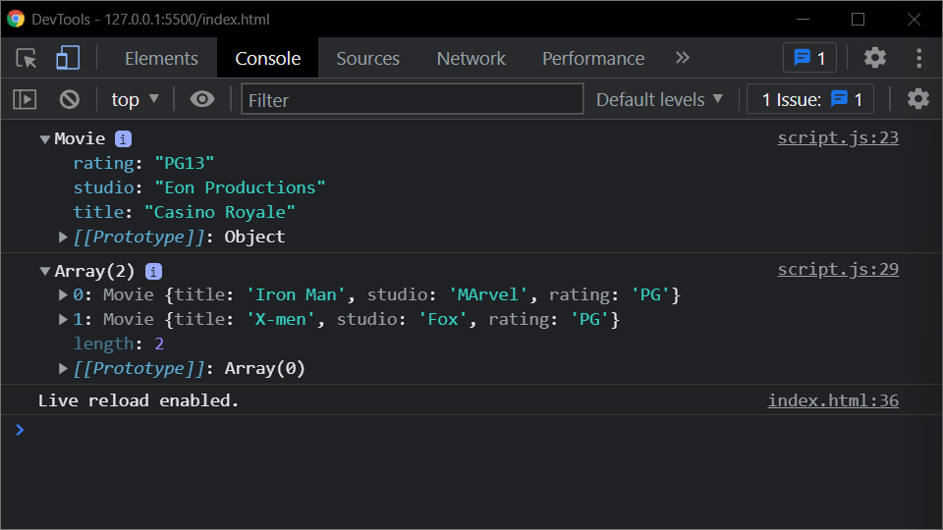

1. ***https://github.com/rvsp/typescript-oops/blob/master/Practice/class-circle.md***

***//creating Circle class***

***class Circle{***

***//declaring cunstructor having default values of radius and color***

***constructor(radius=1.0,color="red"){***

***this.radius = radius;***

***this.color = color;***

***console.log("Object Created");***

***}***

***//returns radius***

***getRadius(){***

***return this.radius***

***}***

***//sets or updates Radius***

***setRadius(radius)***

***{***

***this.radius = radius;***

***}***

***//returns color***

***getColor(){***

***return this.color;***

***}***

***//sets or updates color***

***setColor(color){***

***this.color = color;***

***}***

***//returns the object in String Format***

***toString(){***

***return `Circle[radius=${this.radius},color=${this.color}]`;***

***}***

***//Returns the area***

***getArea(){***

***return Math.pow(this.radius,2)*3.24***

***}***

***//returns the circumference***

***getCircumference(){***

***return this.radius*2*3.14***

***}***

***}***

***//creating instance of Circle Class***

***let obj1 = new Circle;***

***//checking all the functions***

***console.log(obj1.toString());***

***console.log(obj1.getArea());***

***console.log(obj1.getCircumference());***

***console.log(obj1.getRadius());***

***obj1.setRadius(3);//updating radius***

***console.log(obj1.getRadius());***

***console.log(obj1.getColor());***

***obj1.setColor("yellow");//updating color***

***console.log(obj1.getColor());***

***console.log(obj1.toString());//updated details***

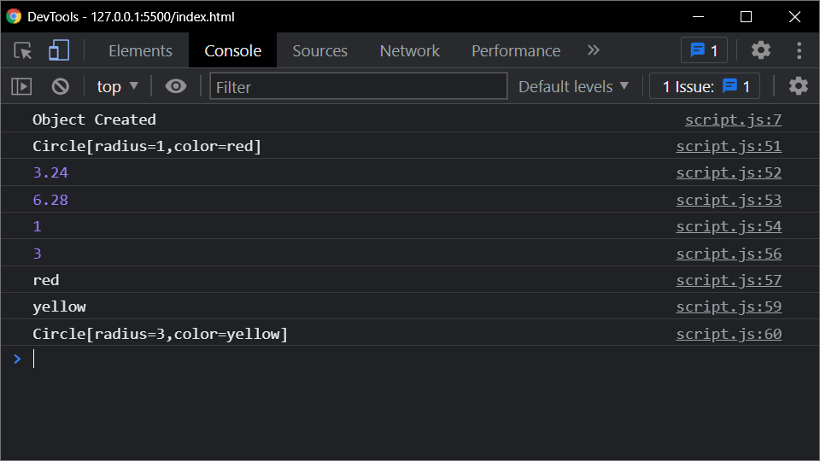

1. ***Write a “person” class to hold all the details.***

***//creating cass person***

***class Person{***

***//construction having details as parameters***

***constructor(name,age,gender,phno,city)***

***{***

***this.name = name;***

***this.age = age;***

***this.gender = gender;***

***this.phno = phno;***

***this.city = city;***

***}***

***//getdetails function to print details***

***get_details(){***

***console.log(` name : ${this.name}\n age : ${this.age}\n gender : ${this.gender}\n phno : ${this.phno}\n city : ${this.city}`);***

***}***

***}***

***//creting object of class Person***

***let new_person = new Person("Himal",20,"Male",1234,"Bharuch")***

***//calling getdetails function for new_person object***

***new_person.get_details()***

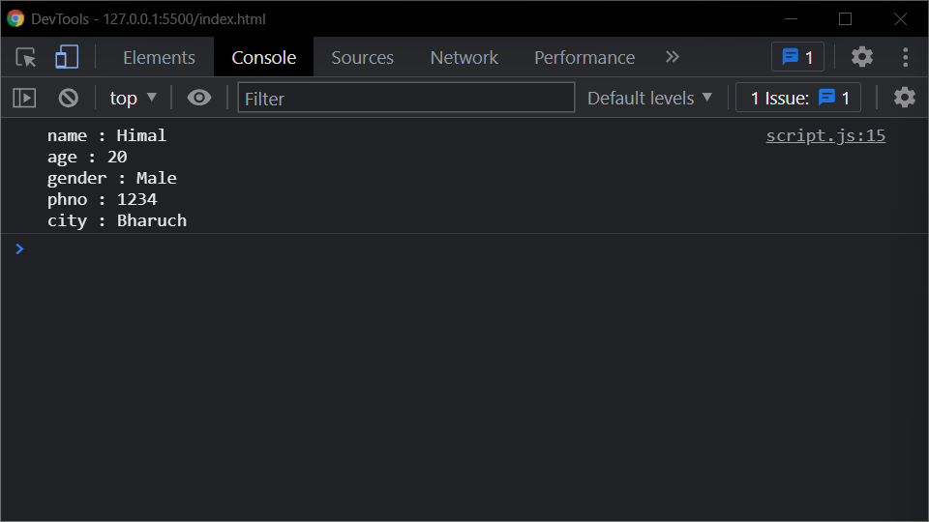

1. ***write a class to calculate uber price.***

//creating Uber Class

class Uber{

//creating cunstructor having cartype,time and distance as arguments

constructor(car,time,distance){

//assigning values

this.car = car;

this.time = time;

this.distance = distance;

}

//method to get price

calculatePrice(){

let Cartypes = {"SUV":500,"UberX":300,"UberBlack":200}

let CostPerMinute = 20

let CostPerMile = 100

let bookingFee = 100

let BaseFare = Cartypes[this.car]

return BaseFare + (CostPerMinute*time) + (CostPerMile * distance) + bookingFee;//returning result

}

}

//creating instance of class Uber

let temp1 = new Uber("SUV",30,5)

//geting the price of ride

console.log(temp1.calculatePrice());

